EXPERIMENT NO 6

1.To Remove specific element from the array
Index.html
<!DOCTYPE html>
<html>
<head>
<title>Remove Element from Array</title>
</head>
<body>
<h2>Remove Element from Array</h2>
<label>Enter Array Elements (comma separated):</label>
<input type="text" id="arrayInput"><br><br>
<label>Enter Element to Remove:</label>
<input type="text" id="removeInput"><br><br>
<button onclick="removeArrayElement()">Remove Element</button>
<p id="result"></p>
<script src="script.js"></script>
</body>
</html>

Script.js function removeArrayElement() { let arr = document.getElementById("arrayInput").value.split(","); let element = document.getElementById("removeInput").value.trim(); let index = arr.indexOf(element); if (index !== -1) { arr.splice(index, 1); document.getElementById("result").innerHTML = "Updated Array: " + arr.join(", ");
} else {
document.getElementById("result").innerHTML = "Element Not Found!";
}
}
Output
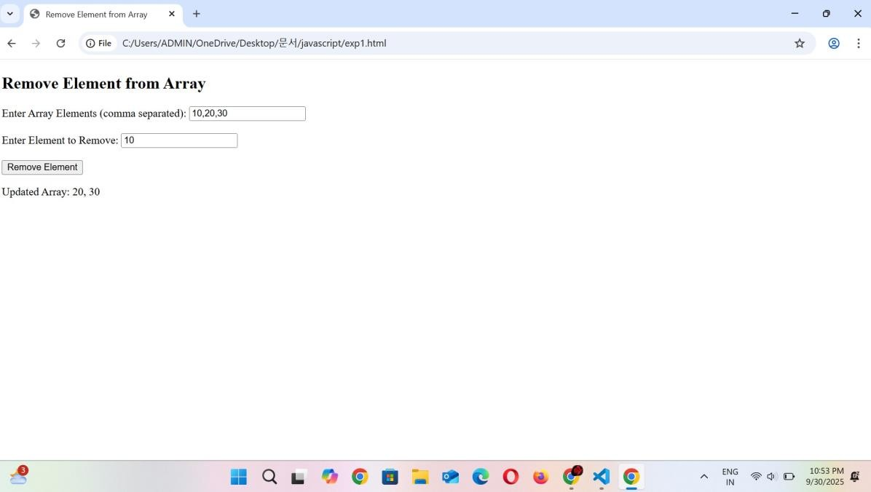

2.Check if an array contains a specified value
Index.html
<!DOCTYPE html>
<html>
<head>
<title>Check Element in Array</title>
<script src="script.js" defer></script>
</head>
<body>
<h2>Check if Element Exists in Array</h2>
<label>Enter Array Elements (comma separated):</label>
<input type="text" id="arrayInput"><br><br>
<label>Enter Element to Check:</label>
<input type="text" id="checkInput"><br><br>
<button onclick="checkArrayElement()">Check Element</button>
<p id="result"></p>
</body>
</html>

Script.js function checkArrayElement() { let arr = document.getElementById("arrayInput").value.split(","); let element = document.getElementById("checkInput").value.trim(); let index = arr.indexOf(element); if (index !== -1) { document.getElementById("result").innerHTML = "Element '" + element + "' found at
index " + index;
} else {
document.getElementById("result").innerHTML = "Element Not Found!";
}
}

Output
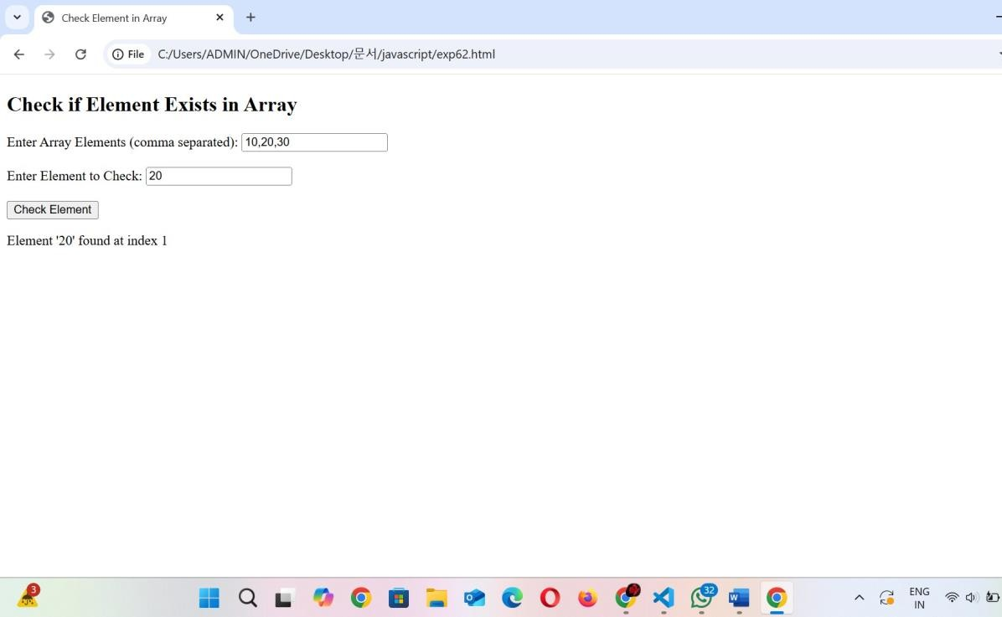

3.To empty an array
Index.html
<!DOCTYPE html>
<html>
<head>
<title>Empty Array Elements</title>
<script src="script.js" defer></script>
</head>
<body>
<h2>Empty Array Elements</h2>
<!-- Input for array elements -->
<label>Enter Array Elements (comma separated):</label>
<input type="text" id="arrayInput"><br><br>
<button onclick="emptyArrayElements()">Empty Array</button>
<h3>Result:</h3>
<p id="result"></p>
</body>
</html>

Script.js
function emptyArrayElements() { let arrayInput = document.getElementById("arrayInput").value; let arr = arrayInput.split(',').map(item => item.trim()); arr.length = 0; document.getElementById("result").textContent = "Array after emptying: [" + arr + "]";
}

Output
